A

MINI PROJECT SYNOPSIS

ON

AIRTRACK

SUBMITTED BY

Ms.MOHITE GAURI UTTAM.

Ms. PATIL VARSHA VIKAS.

Ms.CHEKE SNEHA PRABHAKAR.

GUIDED BY

Asst. Prof. Jadhav P. S.



**Department of Computer sci & engg.**

D. Y. Patil Technical Campus. Talsande

Dist- Kolhapur Tal - Hatkanangale 416112

**Problem statement:-**

To compute the length of the longest landing strip that can be built on the island.

**Objective:**

To construct the Airtrack on polygon shape island .

**Scope of Project :-**

To design Airtrack on the polygon shape island .

**Introduction:**

In our project named Airtrack we have referred ACM International Collegiate Programming Contest problem from said material we found various problem out of which we design Airtrack system such way that we use the maximum surface area with respect to available area.

For our project we use distance formula to calculate the maximum distance among two points.

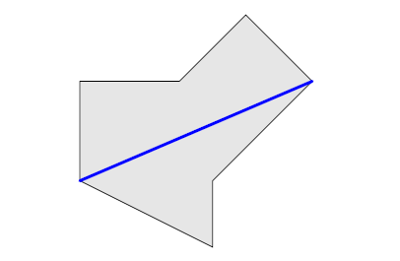

Fig A : the island modeled as a polygon

Given this polygon we need to compute the length of lonest landing strip (i.e. straight line segment) that can be built on the island . The landing strip must not intersect the sea, but it may touch or run along the boundary of the island.

**Sample Input/output:-**

|  |  |
| --- | --- |
| Sample input | Output |
| 3  0 2017  -2017 -2017  2017 0 | 4510.15 |

**Language Used:**

* C++

**Software/Hardware Requirement:-**

**Software requirement**

Operating system: Windows 7 or later versions

Programming Language used: C++

**Hardware requirement**

Processor: Intel core i3 or above

Hard disk: 500 GB

RAM: 2GB

**Conclusion:**

Polygon shape which is not suitable for airport construction by this mini project it is possible to construct the air track on polygon shape island.

**Future Scope :**

* To design the airtrack on any shape island

**Reference :**

* ACM ICPC Problem -A 2017
* www.acmicpc.com
* www.mathc.com